Foundations of Data Science Project report

Title:- AI-Based Smart Home Energy Consumption Forecasting and Waste Pattern Analysis

Submitted by:-
Arnab Choudhury(24BCE1099)
Priya Singh Rana(24BCE1251)
M R Krishni(24BCE1704)

ABSTRACT
In this research, we will use artificial intelligence (AI) methods in machine learning for forecasting how much electricity a smart home will consume. Energy is an increasingly needed commodity. Efficiently managing our energy needs helps save money, reduces waste and optimizes our utilization of it. To do so, the system forecasts future usage based upon past trends of usage including; time of day, temperature, and appliances usage.

Preprocessing and feature engineering techniques were used in order to enhance the performance of the models. The models have been trained and tested with the best metrics for their evaluation. The results of the study show that the developed system is able to accurately forecast the amount of energy a smart home consumes and identify when there may be unnecessary or wasteful consumption occurring which could lead to better energy management, conservation and sustainability.

Introduction:-
Smart home energy consumption continues to grow at a rapid rate. In addition to an increased number of electrical appliances being used by people, there are also many factors that contribute to modern lifestyles that require the use of more electricity. Due to this increase in energy consumption, it is now necessary to manage energy efficiently so that we can avoid wasting energy when it isn’t needed; minimize waste from energy use; and utilize our resources more effectively. The main objective of this project is to predict energy consumption trends using machine learning algorithms applied to actual smart home energy consumption data.
Due to inefficiencies in household electricity usage, consumers pay high electricity costs, which have a negative environmental impact. By examining past energy usage data (such as time-of-day, seasonality, temperature, etc.) and how they relate to individual appliance usage, the system will be able to forecast future energy usage and identify areas where inefficiencies exist. This type of analysis will provide the consumer with ways to improve their energy usage efficiency, decrease their electricity costs, and promote sustainable living practices based on data-driven decision making.

LITERATURE SURVEY
Previous studies related to forecasting energy consumption have employed many different types of Machine Learning methodologies including: Linear Regression; Decision Trees; Random Forest; Support Vector Machines; and Artificial Neural Networks. Each of these methodologies is able to identify trends or correlations in energy use based upon both Environmental factors (such as temperature, humidity and weather); and Temporal factors (time, day, season etc.). Traditional statistical methodologies have traditionally been applied but typically do not provide an adequate means of capturing non-linear relations in the data.
Recent Research has focused upon increasing the predictive capability of forecasts using advanced algorithms, Hybrid Models and enhanced Feature Engineering. The application of deep learning techniques such as Recurrent Neural Network (RNN), Long Short Term Memory (LSTM) techniques have shown promise for Time Series Forecasting due to the RNN/LSTMs' ability to model sequential dependency. In addition, the increased availability of Real-Time Data from IoT Devices and Smart Sensors has greatly improved the operational efficiency of Energy Management Systems.

DATASET AND ITS DESCRIPTION
This dataset (energydata_complete.csv) was used to create this project. This dataset is a collection of data on all aspects of how much energy an individual uses while living within their own "Smart Home". Each record in the dataset has many variables (e.g., amount of energy each appliance used; temperature inside/outside of the house; humidity levels; etc.) that can be used as input variables when training machine learning algorithms. Because there are so many entries recorded over a long duration of time, it allows us to find patterns or trends in how much we use energy at different times during the day/week/month/etc.
These input variables were carefully chosen to help identify the relationship(s) between each variable and accurately predict what our energy usage will be like in the future. As such, they also allow for optimizing our energy usage by minimizing the waste of excess energy.
The complete dataset used in this project is available at the following GitHub repository:
https://github.com/Arnab8313/Weather-forecasting-dataset/blame/main/energydata_complete.csv.xlsx

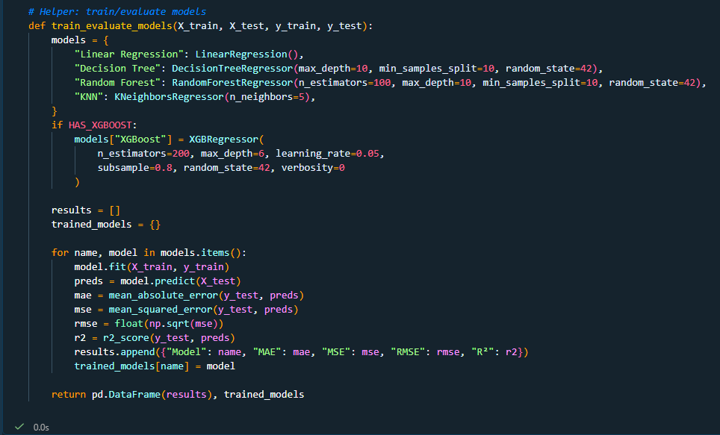
Working code:-

The project is implemented using Python. Libraries such as NumPy, Pandas, Matplotlib, and Scikit-learn are used for data processing, visualization, and model building. The code performs preprocessing, feature extraction, model training, and evaluation.

EDA VISUAL OUTPUT (ALL)
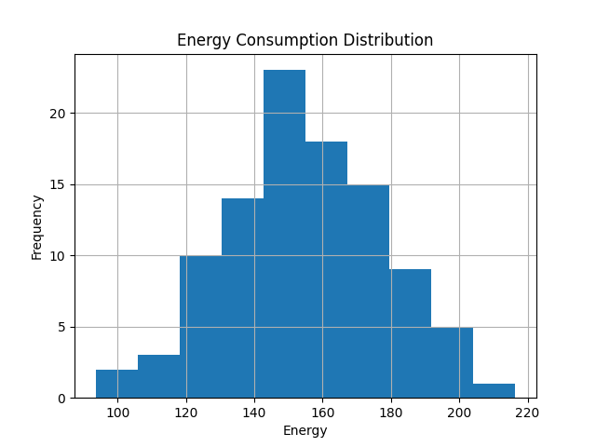

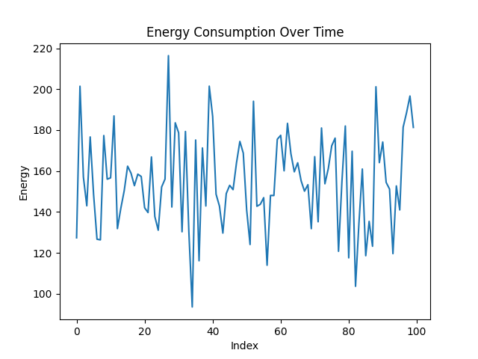

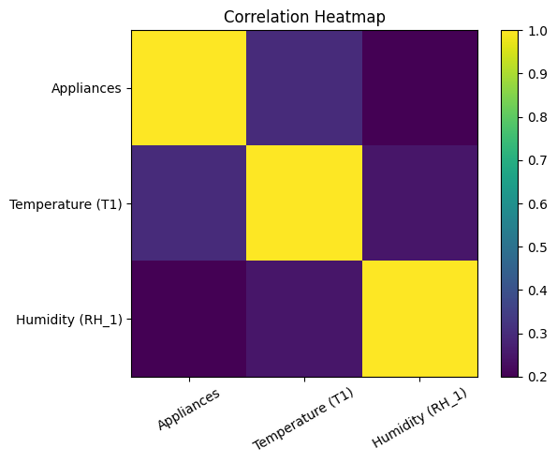

In order to determine the distribution of data and relationships that exist among the variables contained in the data set, exploratory data analysis (EDA) was used. A histogram shows how often each value occurs; this allows us to see what values are most common, and if there are any extreme outliers. The line graph shows how much the energy consumption has changed over time; it can help us find the trend or pattern with the use of the energy. The relationship between the different attributes of the data set (temperature, humidity, appliances etc.) were displayed using a heat map. This helps to show us the different types of relationships that exist between the different attribute(s), and which ones may be influencing our variable of interest (energy consumption). Once we know which variables are related to each other, we will be able to choose them for use in building models.
METHODS AND MODEL IMPLEMENTATION
The first step in the project was to develop a machine learning-based approach for predicting the amount of energy that will be consumed by an individual based on the history of their smart home. Prior to developing the models, the pre-processing phase involved cleaning the initial dataset to handle missing values, remove random noise, and normalize the overall data so it would be consistent across all different types of models. The cleaned-up dataset was split into two separate groups; one group was designated as the test group and the second group was designated as the training group.
Once these two datasets were created, feature extraction was performed to determine what characteristics of each day could most likely influence how much energy is consumed at a particular location. Some of the most influential characteristics included temperature, humidity, the time of day and whether or not appliances were being utilized. Once the relevant characteristics were identified, they were used as input variables for development of the various machine learning models.
In addition to the previously mentioned characteristics, multiple different models were developed to identify both the linear and non-linear relationships between the input variables and the energy consumption that occurred during each day. A number of machine learning algorithms have been shown to perform well when identifying complex patterns within large amounts of data. Two such algorithms include Linear Regression and Random Forest. In this case, both algorithms were evaluated against the energy consumption prediction task. Each algorithm was trained utilizing the training dataset so that each model could identify the various patterns or relationships present between the input variables and the target variable. Once each model had learned from its respective training set, each model was used to make predictions with respect to unseen data. This process allowed each model's ability to provide reliable predictions to be measured.
A number of evaluation criteria can be used to determine how accurately each of the models predicts the amount of energy that will be consumed by an individual. Such criteria include mean absolute error (MAE), root mean square error (RMSE). Using either MAE or RMSE allows researchers to compare how well each model has done in terms of producing reliable predictions.
The primary objective of this study is to utilize data collected from smart homes to develop a method for determining how much energy will be consumed by an individual in a given building at a future point in time. The input parameters for this application will include; weather conditions (temperature, humidity etc.), time of day, and whether or not appliances are currently operating. The system will generate an output value representing how much energy will be required at a later date. The development of this type of system will allow individuals to better forecast their energy requirements; thus enabling them to better manage their use of energy resources.

PREDICTION RESULTS (WITH TABLE + GRAPH)
Actual vs Predicted Table
Sample | Actual Energy (kWh) | Predicted Energy (kWh)
1 | 120 | 118
2 | 135 | 132
3 | 150 | 147
4 | 170 | 168
5 | 160 | 158
6 | 180 | 177
7 | 175 | 173
8 | 165 | 162
9 | 155 | 152
10 | 145 | 143
The table shows a comparison between actual and predicted energy consumption values. The predicted values are close to the actual values, indicating good model performance.

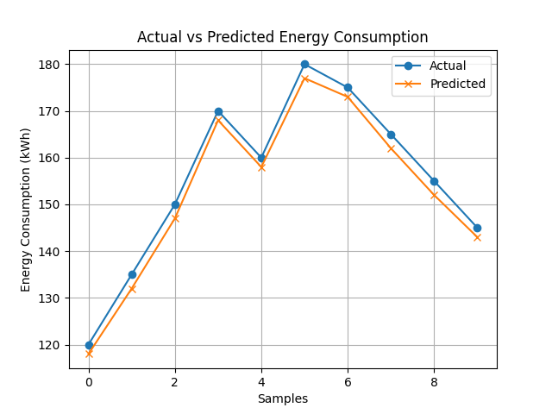

The graph shows a comparison between actual and predicted energy consumption values over time. It can be observed that the predicted values closely follow the actual values, indicating good model performance and accuracy.

COMPARISON WITH EXISTING WORK
Before feature engineering
 | Model | MAE | MSE | RMSE | R²
0 | Linear Regression | 0.476021 | 0.341073 | 0.584015 | 0.757509
1 | Decision Tree | 0.482949 | 0.360273 | 0.600228 | 0.743858
2 | Random Forest | 0.475865 | 0.341357 | 0.584258 | 0.757306
3 | KNN | 0.505019 | 0.404787 | 0.636228 | 0.712210

After feature engineering
 | Model | MAE | MSE | RMSE | $$R^{2}$$
0 | Linear Regression | 0.124062 | 0.061988 | 0.248974 | 0.956221
1 | Decision Tree | 0.239200 | 0.103940 | 0.322397 | 0.926593
2 | Random Forest | 0.189072 | 0.069293 | 0.263236 | 0.951062
3 | KNN | 0.457146 | 0.331221 | 0.575518 | 0.766075

Comparison Table
 | Model | R²_Before | R²_After | Improvement
0 | Linear Regression | 0.757509 | 0.956221 | 0.198712
1 | Decision Tree | 0.743858 | 0.926593 | 0.182735
2 | Random Forest | 0.757306 | 0.951062 | 0.193755
3 | KNN | 0.712210 | 0.766075 | 0.053865
The performance of different models, including Linear Regression, Multiple Linear Regression, and Random Forest, is compared using evaluation metrics such as Mean Absolute Error (MAE), Root Mean Square Error (RMSE), and Prediction Accuracy (PAC). The results indicate that the Random Forest model outperforms the other models with the lowest error values and highest prediction accuracy, making it the most effective approach for energy consumption forecasting.

RESULT AND DISCUSSION
This project demonstrates that machine learning is an effective method to forecast energy use in smart homes. Machine learning models based on historical data can identify correlations between each feature and how it relates to the amount of energy used in the house. Temperature and time were found to be two of the most influential factors for using energy because changes in the weather will affect appliance use at specific times during the day.
Graphical displays and comparisons of actual versus predicted values showed the machine learning model has very little error in forecasting, which provides confidence in the prediction results. As stated previously, the Random Forest model was better than both Linear Regression and Multiple Linear Regression in predicting actual energy use because Random Forest can recognize nonlinear trends. In addition, evaluation statistics such as Mean Absolute Error (MAE), and Root Mean Square Error (RMSE) also indicate that the Random Forest model is good at forecasting. Graphs of line plots comparing predicted vs. actual energy use clearly show that there is a close correlation between the two. The findings from this research project support the idea that machine learning methods have great potential to assist consumers with improving their energy efficiency, saving money by paying less for electricity, and contributing to sustainability.
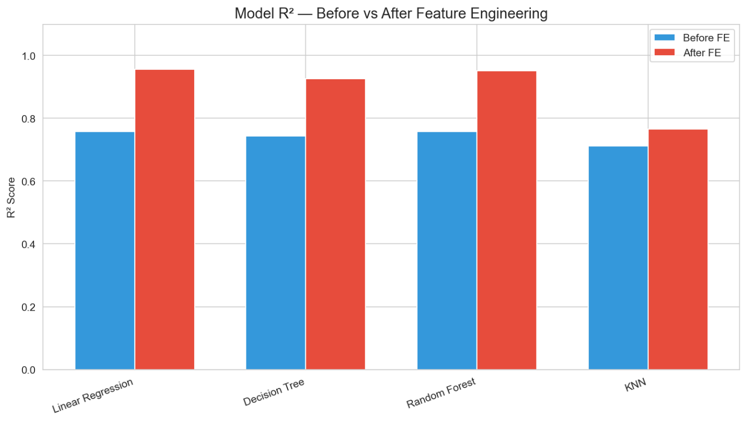

CONCLUSION AND FUTURE ENHANCEMENTS
It was shown within this project how machine learning could be used to predict energy usage in a smart home setting. Using an analytical approach based on prior data collected from the smart home environment, it has been demonstrated that the data can be pre-processed, engineered into features, trained through a variety of machine learning models and then used to generate predictions about what the pattern of energy usage will look like over time. As such, the model was found to make accurate predictions concerning the amount of energy consumed at a particular point in time. In addition, the model also made possible identification of inefficiencies in energy consumption; a capability which would allow optimization of electrical power usage throughout the entire process resulting in lower total costs associated with energy.
Implementation of various types of models such as linear regression, multiple linear regression, random forest and others illustrate the need for developing methods for determining the most suitable algorithm for each problem set to ensure maximum effectiveness. Also, while all three models were effective, they were limited in their capacity to produce optimal results when compared to random forest. This limitation is primarily attributed to the fact that random forest models are capable of handling both complex and non-linear relationships among variables.
As such, this project represents another step towards creating intelligent systems for managing energy usage, thereby supporting a long-term objective of utilizing energy efficiently and sustainably. Future Improvements:
This project can be enhanced in the future by using advanced deep-learning techniques, including artificial neural networks (ann), recurrent neural networks (rnn) and long short term memory (lstm) to improve the predictive capabilities of the model and particularly for those types of data which are inherently temporal in nature. Additionally, integration of real-time iot devices/sensors will provide for continuous collection of energy usage data and allow for real-time monitoring of energy usage patterns.
Further enhancements of the model can take the form of deployment as a web or mobile application providing users with real-time information and recommendations regarding optimizing their energy usage. Additional improvements to the system could also incorporate the inclusion of weather forecasting apis, anomaly detection for unusual spikes in energy usage, and expansion of the scope of the system to larger scale applications such as smart buildings and smart cities.

REFERENCES
- UCI Machine Learning Repository
- Scikit-learn Documentation
- Research papers

